**Practical 11**

**AIM**: Write a program for Manipulation of String using operators.

**OBJECTIVES:**

**2) Implement a C++ program for Manipulation of String using operators. Design the String class and a parameterized constructor to initialize strings. Define friend functions to overload + operator to concatenate two strings and overload >= operator to compare two strings.**

#include <iostream>

#include <string.h>

using namespace std;

class String{

char a[100];

public:

String(){

strcpy(a,"");

}

String(char *p){

strcpy(a,p);

cout<<a<<endl;

}

friend String operator +(String obj1 , String obj2);

void display(){

cout<<"The string is : "<<a<<endl;

}

friend void operator >=(String obj1,String obj2);

};

String operator +(String obj1,String obj2){

String temp;

strcpy(temp.a,strcat(obj1.a,obj2.a));

return temp;

}

void operator >= (String obj1,String obj2){

if(strlen(obj1.a) > strlen(obj2.a)){

cout<<obj1.a<<" is greater than or equal to "<<obj2.a<<endl;

}

else{

cout<<obj1.a<<" is smaller than "<<obj2.a<<endl;

}

}

int main()

{

String obj1("New ");

String obj2("York");

String obj3;

obj3 = obj1 + obj2;

obj3.display();

String obj4("New Delhi");

obj1 >= obj4;

return 0;

}

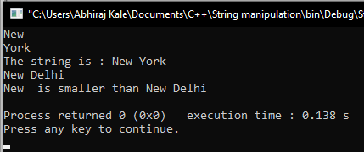

**CONCLUSION:**

Hence, we have successfully written a program for Manipulation of String using operators.